POWER BI WEEK 5 PROJECT REPORT

Healthcare Data Analysis – Data

NAME : KEERTHANA .R

DEPARTMENT : BSC DS AND AI

1. Introduction

In Week 5, the healthcare dataset was prepared and structured in Microsoft Power BI for further analysis. Data modelling was performed by creating dimension tables, a fact table, a date table, and appropriate relationships between the tables. DAX measures were also created to calculate important healthcare metrics.

2. Objective

The main objectives of Week 5 were:

* To prepare the healthcare dataset for analysis.
* To create dimension and fact tables.
* To create a proper Date Table.
* To establish relationships between tables.
* To create DAX measures for healthcare analysis.
* To prepare the data model for dashboard development in Week 6.

3. Data Model

The following tables were used in the healthcare data model:

* **DIM Patient** – Contains patient-related information.
SELECTED COLUMNS :
->Names
->age
->gender
->blood type
->medical condition
->age_group(created using conditional columns )
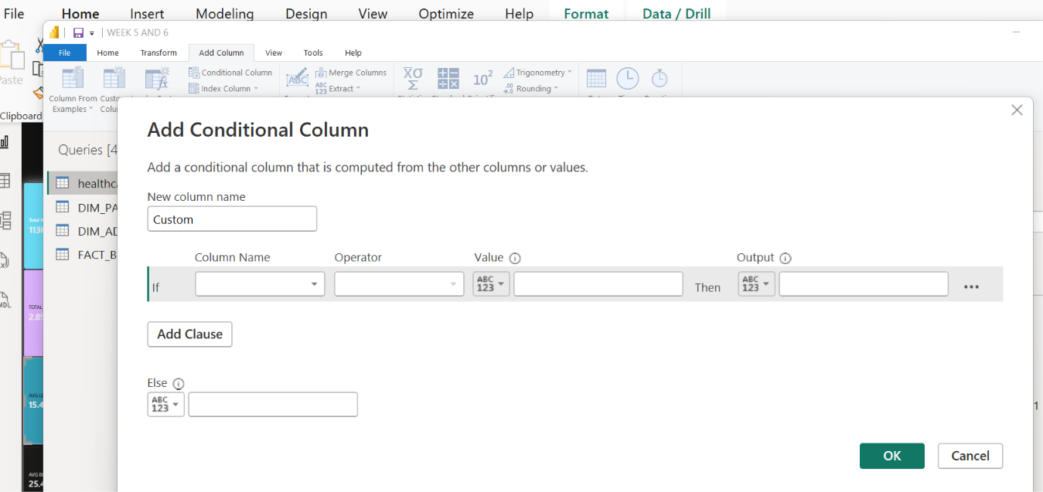

->Patient_id(index column [from 1])
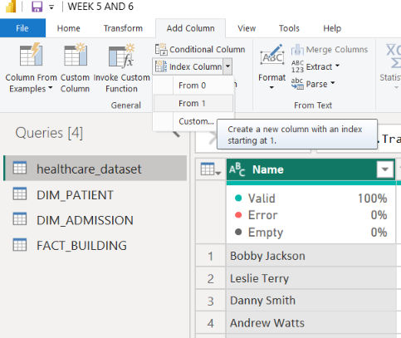
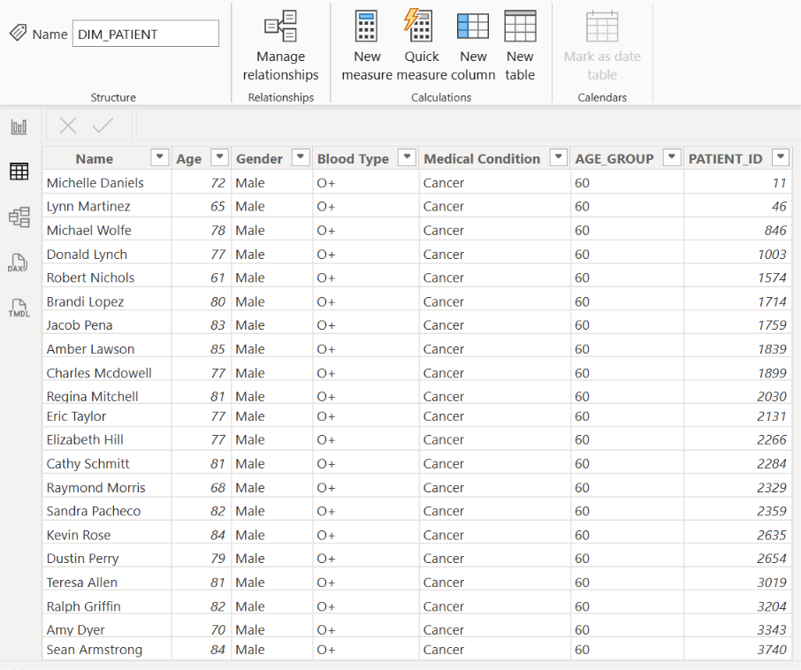

* DIM Admission** – Contains admission and discharge information.
->admission type

->admission id (index column )
->date of admission
->discharge date
->doctor
->hospital
->insurance provider
->room number

* Fact_Billing / Fact Building** – Contains the main analytical records.
->admission type
->billing amount
->date admission
->discharge date
->Dim patient_ patient id
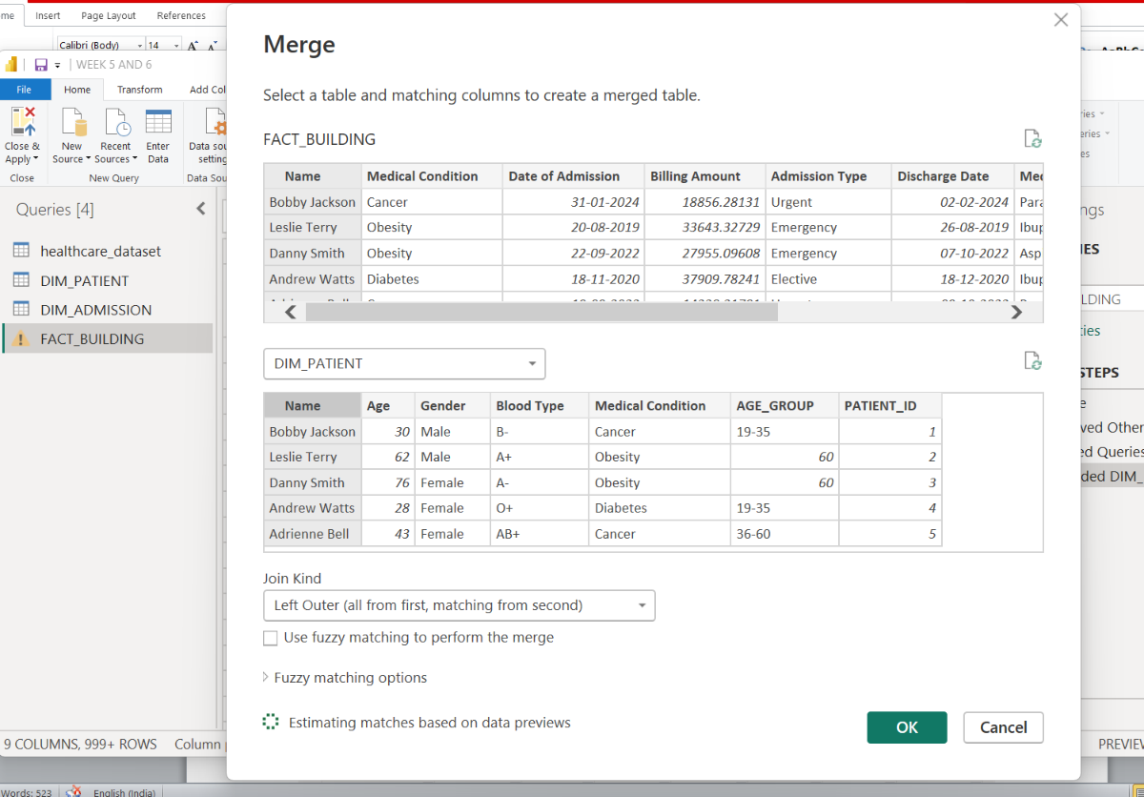
->medical condition
->medication
-> name
->test results
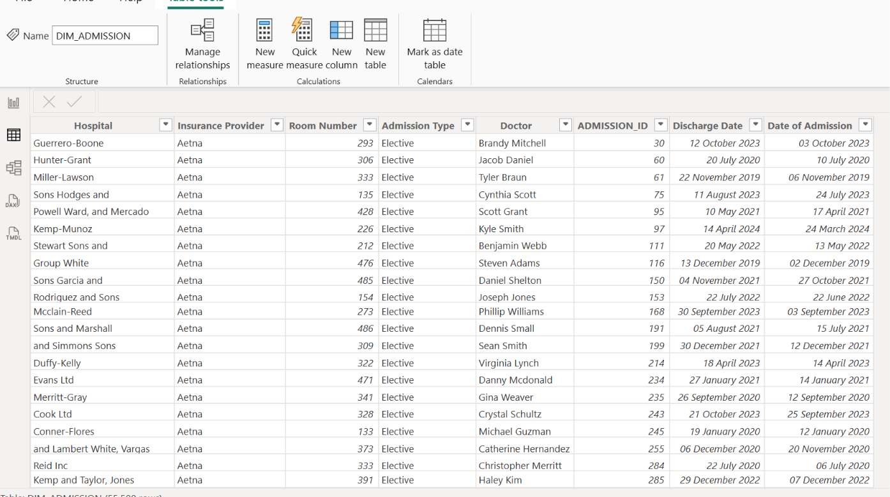

* DimAdmissionType** – Contains different admission types.
->Admission type
->avg billing amount
->avg length of stay
->readmission rate
->total admission
->total billing amount
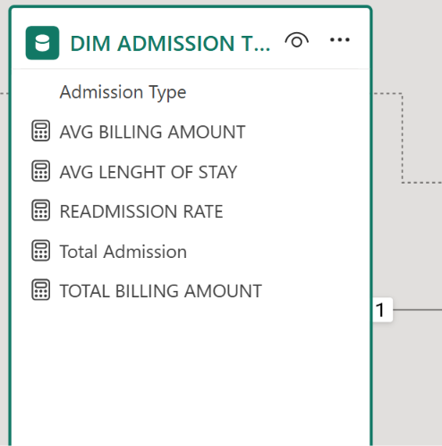

* DimDate** – Contains the date dimension used for time-based analysis.
->date
->month
->month no
->year
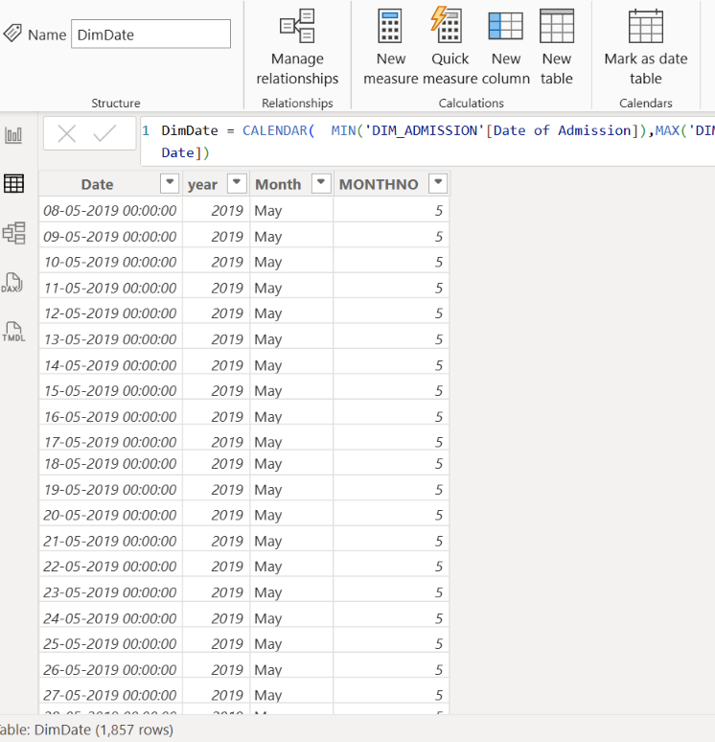

4. Date Table

A separate Date Table was created using DAX to support time-based analysis.

The Date Table contains:
Creation:
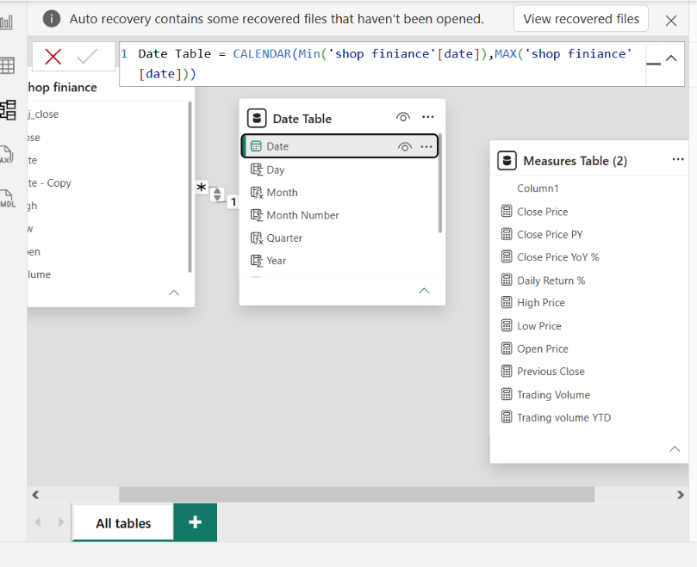

* Date
Format: DimDate = CALENDAR( MIN('DIM_ADMISSION'[Date of Admission]),MAX('DIM_ADMISSION'[Discharge Date])

* month
Format: Month = FORMAT(DimDate[Date],"MMMM")

*year
Format: year = YEAR(DimDate[Date])

* Month Number
Format: MONTHNO = MONTH(DimDate[Date])

The Month column was sorted using Month Number to maintain the correct chronological order.

5. Relationships

Relationships were created between the dimension tables and fact table to build a proper data model.

The major relationships include:

* **DIM Patient → Fact building **
* **DimAdmissionType → Fact _building**
* **DimDate → DIM Admission**
* **DimDate → Fact building **

The relationships were configured using appropriate one-to-many cardinality and single cross-filter direction.
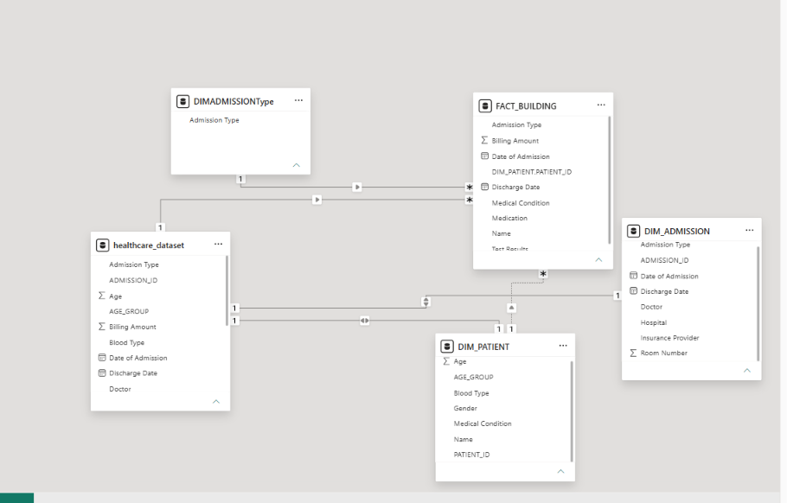

6. DAX Measures

The following measures were created for healthcare analysis:

**Total Admissions**

```DAX
Total Admissions = COUNTROWS(Fact_Billing)
```

**Total Billing Amount**

```DAX
Total Billing Amount =
SUM(Fact_Billing[Billing Amount])
```

**Average Billing Amount**

```DAX
Avg Billing Amount =
AVERAGE(Fact_Billing[Billing Amount])
```

**Average Length of Stay**

```DAX
Avg Length of Stay =
AVERAGEX(
Fact_Billing,
DATEDIFF(
Fact_Billing[Date of Admission],
Fact_Billing[Discharge Date],
DAY
)
)
```

**Readmission Rate**

```DAX
Readmission Rate =
VAR TotalPatients =
DISTINCTCOUNT(Fact_Billing[PatientKey])
VAR RepeatPatients =
COUNTROWS(
FILTER(
SUMMARIZE(
Fact_Billing,
Fact_Billing[PatientKey],
"AdmissionCount", COUNTROWS(Fact_Billing)
),
[AdmissionCount] > 1
)
)
RETURN
DIVIDE(RepeatPatients, TotalPatients, 0)
```

7. Week 5 Outcome

At the end of Week 5, the healthcare dataset was successfully transformed into a structured data model. Dimension tables, fact table, date table, relationships, and DAX measures were prepared for visualization.

The prepared model will be used in Week 6 to create an interactive healthcare dashboard.

